Assignment 5

Challenge:2

* CodeGraphical user interface, text, application

  Description automatically generated

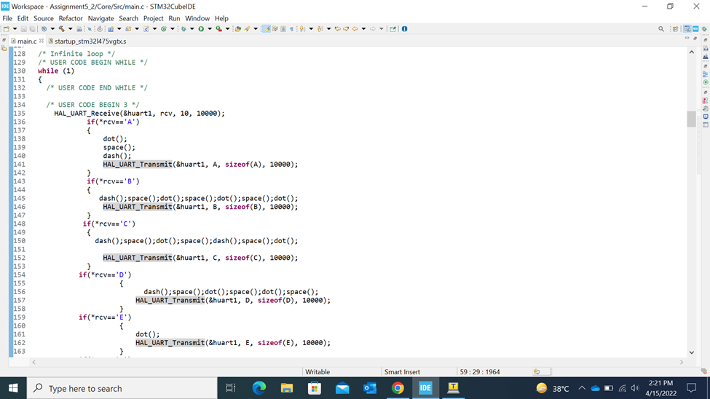

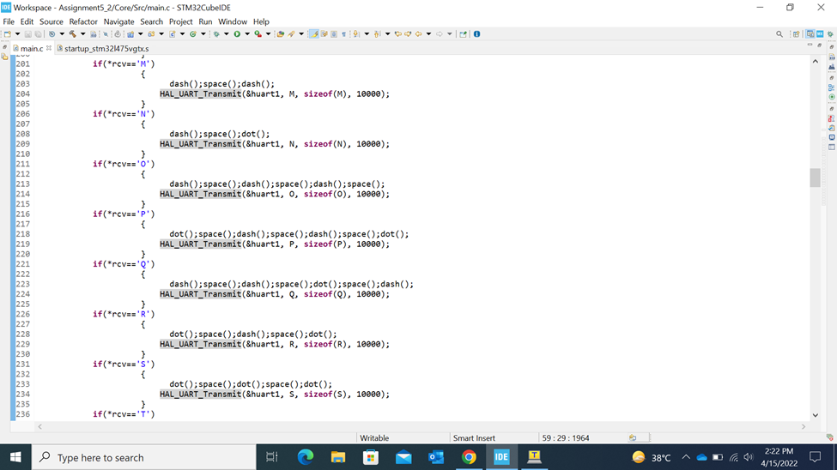

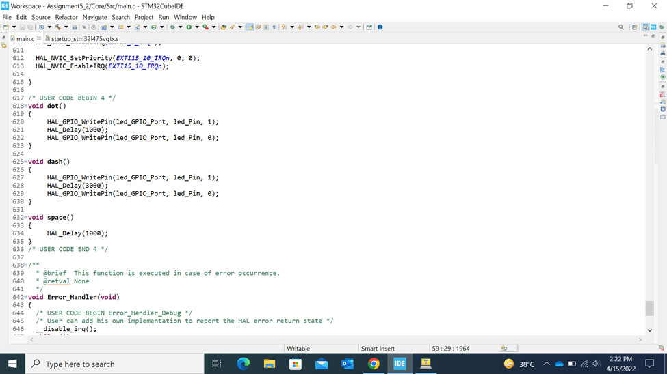

* Output:

<https://drive.google.com/file/d/12oAsqt0EGz6H6XS9cxTcNhRJiavTyhEy/view?usp=sharing>